Michael Angelo A. Barbin
BSIT2C

Boy |  |  |  |  |  | Ice cream

Hustband |  |  |  |  |  | Wife

Student |  |  |  | Teacher

Player |  |  |  | Team

Doctor |  |  |  | Nurse

Artist |  |  |  | Song

Name
Address
Manufact
urer
Flavour
Eats
Phone
Price
Boy
Boy

Name
Address

Volume No.
Author
Name
Address
Writes
Phone No.
Reader

Name
Gender

ID No.
Employee
Works
Company
Name
Name
Address

Presidency Line-up
President
Govern
Continent
Name

Room Section
Department

Country Code
Country

Company
Name Address Supplier key*
Supplier
Name: Gender Address: Zip code Mobile no.
Employee
Name: Address: Mobile no.
SAD Sari-Sari Store (Point
of sale)
Costumer
Owner
Name: Address: Gender: Mobile no.
Admin’s mobile no. Employee’s mobile no. Name
Zip code City Province Supply key
Store mobile no.

Product Brand ID*
Supplier key*
Zip
City Brand ID Product ID

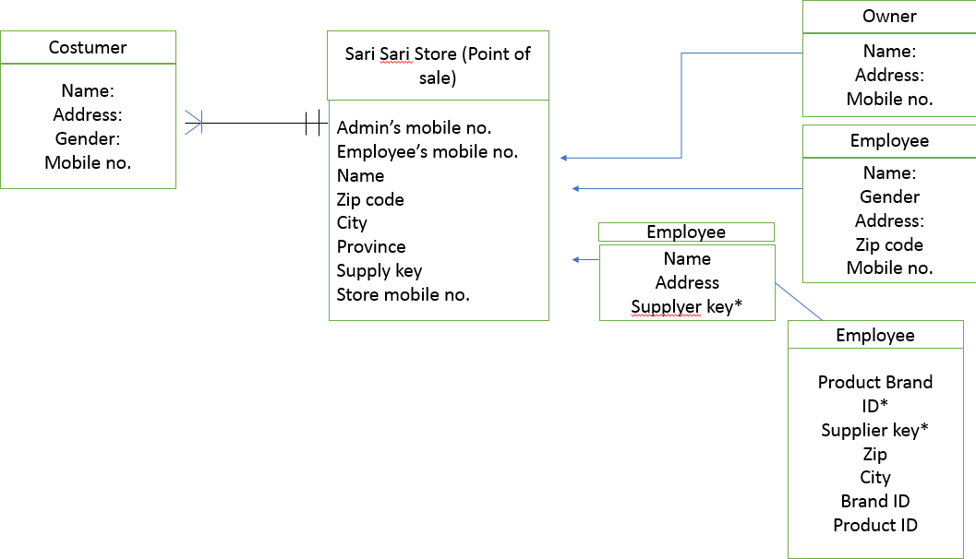
City Zip code
State
City
Zip code
Address
name
Brand Id* Product Id* Suppliers key* City
Zip code
State
Company
Supplier
Key* Name
Address
Supplier
Product ID* Product Name
Brand ID*
Brand Name
Product
Brand
Address
City Zip code
Address

Address
Name
Costumer
Name
Mobile No.

Gender

Mobile No.
Buyer Admin

Name Mobile
No.

Addres s
Owner

Name Address

SAD Sari Sari Store
(Point of sale)

Address Product
WORK
Employee

Gender Mobil e No.

Supply
Address

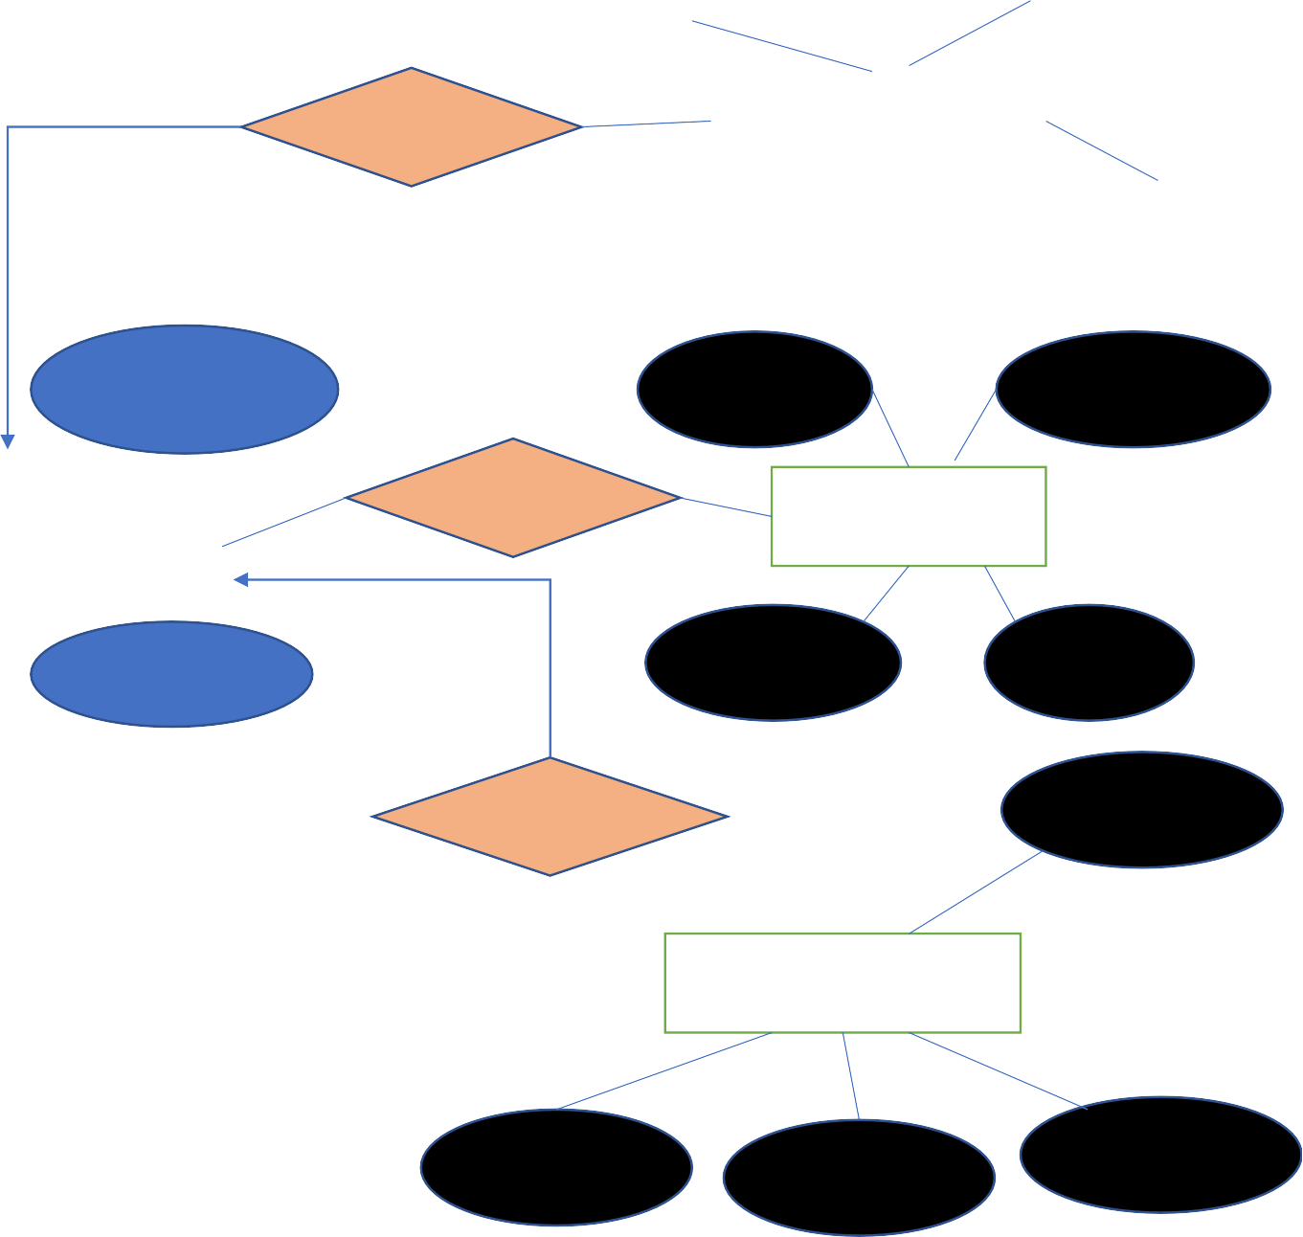
Name

Address Product ID*

Company

Mobile No.

Supplier

Name

Supplier Key

