Name: | Zenshin Systems Corporation
Head Office: | #25 General Roxas Street corner Tangali Street, Barangay San Jose, Quezon City, Metro Manila, 1115 Philippines
Contact: | Mobile: +63 2 3650536  Email: inquire@zenshin.com.ph
About: | “Since 1989, Zenshin has been helping organizations leverage cost-effective ICT solutions. Our constant evolving strategy has kept us in sync with the fast changing pace of the ICT industry. Our focus on customer service has always been our #1 priority.  Zenshin will always be your reliable partner.”
Company Type: | Local Reseller
Offered Products: | Lenovo
Website: | http://www.zenshin.com.ph

Name: | Senco Link Technologies
Head Office: | 4th Floor 1st Life Building, 174 Salcedo Street, Legaspi Village, Makati City, Philippines
Contact: | Mobile: +63 2 8934103 / 8160699 / 8127730
About: | “Senco Link Technologies provides total solution systems for various sized enterprises. We are an established provider of the best upscale technology that helps companies increase productivity, improve their efficiency and reduce operation costs.  Be it in the field of advertising, broadcasting, post-production houses, BPO's, pharmaceutical and others, we supply the right tools and programs that suit each enterprise's needs. Contact us to find out in what other ways we can help you.”
Company Type: | Apple Reseller
Offered Products: | Apple
Website: | https://www.sencolink.com/enterprise

Name: | Samsung Group
Head Office: | Seoul, South Korea
Contact: | Email Support  For Other Products & Inquiries:  02-4222111 [Standard Landline] / 1-800-10-7267864 [PLDT Toll Free] / 1-800-8-7267864 [Globe Toll Free]  For Mobile Devices:  02-4222177 [Standard Landline] / #Galaxy (#425-299) [PLDT  / Smart / Sun Cellular] / 1-800-8-7267777 [Globe Toll Free]
About: | “The digital age has brought revolutionary change and opportunity to global business and Samsung Electronics has responded with advanced technologies, competitive products and constant innovation.  With success of its electronics business, Samsung has been recognized globally as an industry leader in technology and now ranked as a top 10 global brand.”
Company Type: | Multinational Conglomerate Company
Offered Products: | All Samsung products
Website: | https://www.samsung.com/ph/
Name: | Nexus Technologies Inc.
 | 
Head Office: | G/F Don Pablo Building, 114 Amorsolo Street Legaspi Village, Makati City 1229 Philippines
Contact: | Mobile: +632 555 2400 / +632 867 1191  Email: sales@nexustech.com.ph
About: | Nexus is a prominent force in the information technology industry in the Philippines, having carved a niche as the systems integrator and corporate IT reseller of choice of a number of the country’s top corporations.  Nexus offers a full breadth of products and services that boast quality, reliability, and the most value in their category supplied only by leading IT companies.
Company Type: | Local Reseller
Offered Products: | 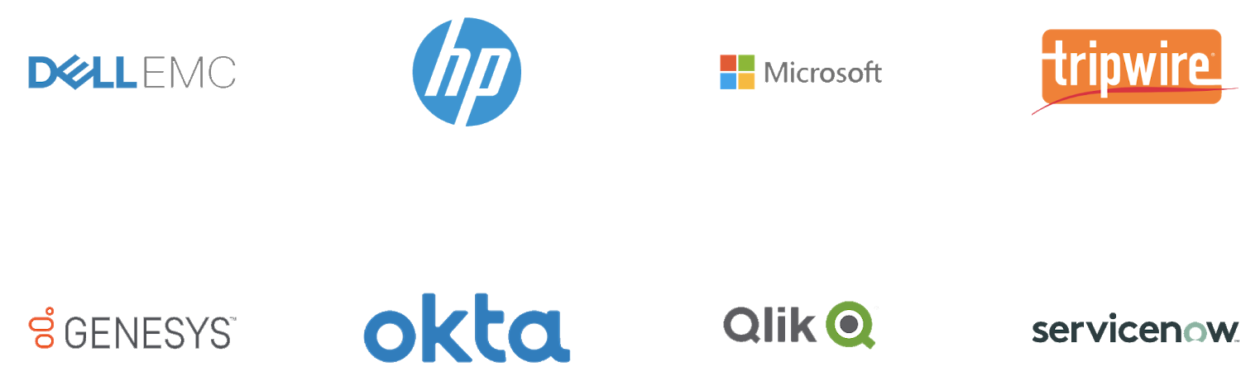
Website: | https://www.nexustech.com.ph/company/about-us/our-story  /

